Adding Conference Room Calendar to Outlook for Windows PC

- Go to your Calendar
- Select ‘Open Calendar’
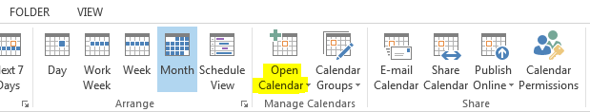
- Select ‘Open Shared Calendar’ from dropdown menu
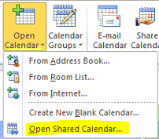
- In search box, type Conference Room Schedule and click OK
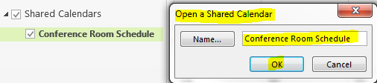
- Now on the left hand pane, you will see a ‘Shared Calendar’ group with ‘Conference Room Schedule’ underneath. While you have this checked, you’re able to see the Calendar.

Attention Mac users: Please contact vgssupport@vgs-inc.com to add this for you.

